Type Script

TypeScript is a typed superset of JavaScript

TypeScript consists of three separate, but mutually fulfilling parts:

* The language
* The compiler
* The language Service

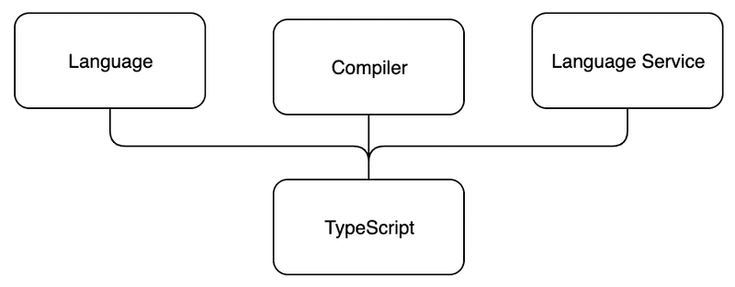

*The language* consists of syntax, keywords and type annotations.

*The compiler* is responsible for type information erasure (i.e. removing the typing information) and the code transformations.

*The language service* collects type information from the source code. Development tools can use the type information for providing intellisense, type hints and possible refactoring alternatives.

**TypeScript key language features**

#### Type annotations => (Declaring)

#### Structural typing => (matching or assigning)

#### Type inference => (inferred)

#### Type erasure

### Why should one use TypeScript?

**First** of all, TypeScript offers *type checking and static code analysis*.

The **second** advantage of TypeScript is that the type annotations in the code can function as a type of *code level documentation*.

Types can be reused all around the code base, and a change to a type definition will automatically reflect everywhere the type is used.

The **third** advantage of TypeScript is, that IDEs can provide more *specific and smarter intellisense* when they know exactly what types of data you are processing.

### What does TypeScript not fix?

#### Incomplete, invalid or missing types in external libraries

#### Sometimes type inference needs assistance

#### Mysterious type errors